
SERANGOON JUNIOR COLLEGE
General Certificate of Education Advanced Level
Higher 1

CHEMISTRY 8872/01
JC2 Preliminary Examination 25 Aug 2010
Paper 1 MCQ 50 min

Additional Materials: OMS
Data Booklet

READ THESE INSTRUCTIONS FIRST

Write in soft pencil.
Do not use staples, paper clips, highlighters, glue or correction fluid on the OMS.

Follow the instructions given to you on how to fill in the OMS.
Write your name and index number on the OMS in the spaces provided.
Shade correctly the item index number, starting with the number “2” and the last 4 numbers of your FIN/NRIC number.
Eg. If your NRIC is S8906660Z, shade 26660 for the item index number.

There are thirty questions on this paper. Answer all questions. For each question there are four possible answers A, B, C and D.
Choose the one you consider correct and record your choice in soft pencil on the separate OMS

Each correct answer will score one mark. A mark will not be deducted for a wrong answer.
Any rough working should be done in this booklet.

This document consists of 14 printed pages and 0 blank page
Answer ALL Questions

1 | A sample of 0.020 mol of an oxochloride of sulfur, SO₂Cl₂, reacted completely with 250 cm³ of water according to the following equation.  SO₂Cl₂ (l) + 2 H₂O (l) → H₂SO₄ (aq) + 2 HCl (aq)  What would be the volume of 0.1 mol dm⁻³ aqueous sodium hydroxide required to neutralise 10.0 cm³ of the above resulting solution?
 | A | 16.0 cm³
 | B | 32.0 cm³
 | C | 48.0 cm³
 | D | 64.0 cm³

2 | Basic hydrolysis of acetonitrile, CH₃CN, takes place according to the following equation:  CH₃CN + NaOH + H₂O → CH₃COO⁻Na⁺ + NH₃  A sample of acetonitrile was boiled with aqueous NaOH and the NH₃ gas evolved was passed into 50 cm³ of 1.00 mol dm⁻³ of HCl. The excess acid required 26.00 cm³ of 1.00 mol dm⁻³ NaOH solution for neutralisation. What was the mass of acetonitrile used?  (Given M_{r} of CH₃CN = 41.0)
 | A | 0.492 g
 | B | 0.984 g
 | C | 1.07 g
 | D | 1.97 g

3 | In a redox experiment, 15.0 cm³ of 0.2 mol dm⁻³ of acidified manganate(VII) ions was used to oxidise 25.0 cm³ of 0.6 mol dm⁻³ of an aqueous solution of A^{n+}.  What is the change in oxidation number for element A?
 | A | –1
 | B | –2
 | C | +1
 | D | +5

4 | Beams of particles travelling at the same speed from different sources are subjected to an electric field as shown in the diagram below. The path for a beam of neutrons has already been drawn.  source  +  -  neutrons  C  B  D  Which of the following correctly represents the particles labelled B, C and D?
 |  | B | C | D
 | A | ⁴He⁺ | ¹H⁺ | electrons
 | B | ⁴He⁺ | ²H⁺ | ¹H⁺
 | C | ¹H⁺ | ²H⁺ | ³H⁺
 | D | ¹H⁺ | ²H⁺ | electrons

5 | Which diagram represents the arrangement of electrons in the 3rd and 4th quantum shell of a Co²⁺ ion?
 | A | __ __ __ __ __ __ __ __ __ __  3s 3p 3d 4s
 | B | __ __ __ __ __ __ __ __ __ __  3s 3p 3d 4s
 | C | __ __ __ __ __ __ __ __ __ __  3s 3p 3d 4s
 | D | __ __ __ __ __ __ __ __ __ __  3s 3p 3d 4s

6 | Which one of the following statements best explains why the boiling point of butanone (79.6 ºC) is higher than that of pentane (36.1 ºC)?
 | A | The relative molecular mass of butanone is higher than that of pentane.
 | B | The butanone molecule has a larger surface area than the pentane molecule.
 | C | The covalent bonds in butanone molecules are stronger than those in the pentane molecules.
 | D | There are stronger dipole interactions between butanone molecules but only weak interactions between pentane molecules.

7 | The decomposition of hydrogen peroxide was found to be a first order reaction. Which of the following graphs is correct?  A B  Rate of decomposition of H₂O₂  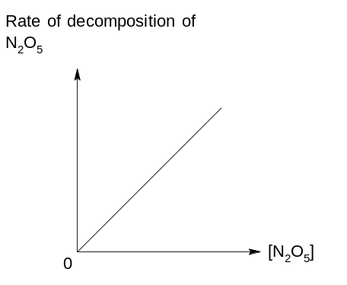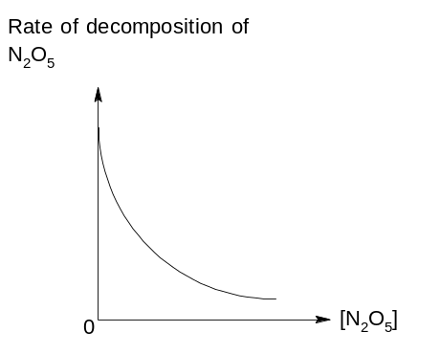  Rate of decomposition of H₂O₂  [H₂O₂]  [H₂O₂]  [H₂O₂]  [H₂O₂]  C D  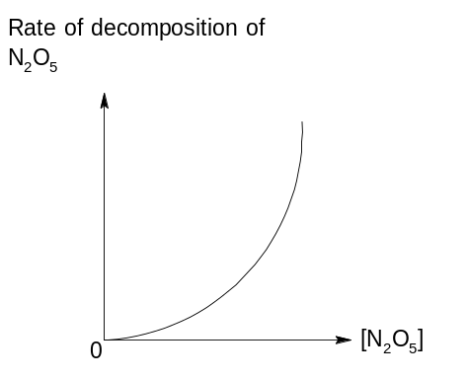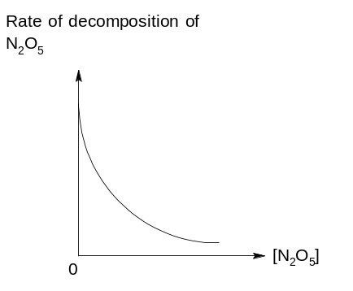  [H₂O₂]  [H₂O₂]  time  time  time
8 | The graph below shows how the percentage of gaseous products present at equilibrium varies with temperature and pressure.  % products at equilibrium  T ºC  (T + 10) ºC  pressure  Which of the following equilibrium correctly represents the graph above?
 | A | H₂ (g) + I₂ (g) 2HI (g) ∆H = + 53 kJ mol⁻¹
 | B | N₂O₄ (g) 2 NO₂ (g) ∆H = + 57 kJ mol⁻¹
 | C | N₂ (g) + 3 H₂ (g) 2 NH₃ (g) ∆H = - 92 kJ mol⁻¹
 | D | 4 NH₃ (g) + 5 O₂ (g) 4 NO (g) + 6 H₂O (g) ∆H = - 950 kJ mol⁻¹

9 | The graph below shows the change in concentrations of the equilibrium mixture with time for the following reaction:  F (g) + 2 G (g) H (g)  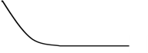  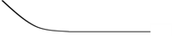  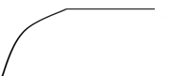  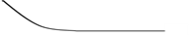  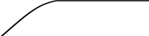  Concentration /mol dm⁻³  F  G  H  T₁  T₂  time  Which of the following shows the correct conditions applied to cause the change at time T₁ and T₂?
 |  | T₁ T₂
 | A | decrease in volume increase in [H]
 | B | decrease in volume decrease in [H]
 | C | increase in volume increase in [H]
 | D | increase in volume decrease in [H]

10 | The following graph shows the pH changes when 0.15 mol dm⁻³ of Ba(OH)₂ is added to 20 cm³ of 0.15 mol dm⁻³ of ethanoic acid.  13  pH  L  K  J  3  Volume of Ba(OH)₂ / cm³  Which of the following statements is true about this titration?
 | A | The equivalence volume for this titration is 20 cm³.
 | B | A buffer region is observed at point J.
 | C | A good indicator that can be used in this titration is universal indicator.
D pH at point K is smaller than 7.

11 | 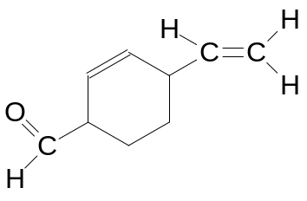  Compound M  Compound M was reacted with hydrogen gas in the presence of palladium catalyst. What is the total number of sigma and pi bonds found in the product formed?  No. of sigma bonds No. of pi bonds
 | A | 21 3
 | B | 25 2
 | C | 26 1
 | D | 28 0

12 | 3-methylpentane was reacted with chlorine gas in the presence of ultraviolet light. What is the total number of possible isomers formed, assuming mono-substitution took place?
 | A | 4
 | B | 5
 | C | 6
 | D | 14

13 | Which of the following shows the correct products formed when buta-1,3-diene undergoes Reaction 1 and Reaction 2 separately?  Reaction 1: With excess cold alkaline KMnO₄ followed by heating.  Reaction 2: With hot acidified KMnO₄.
 |  | Reaction 1 | Reaction 2
 | A | 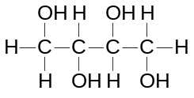 | CO₂ and H₂O
 | B | CO₂ and H₂O | 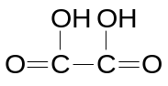
 | C | CO₂ and H₂O | CO₂ and H₂O
 | D | 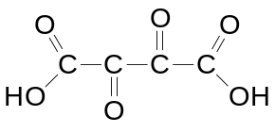

14 | Which of the following is the major product formed when CH₃CH=C(NO₂)CH₂CH=C(CH₃)₂ reacts with HBr?
 | A | 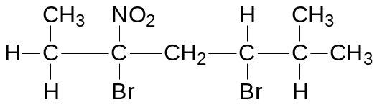
 | B | 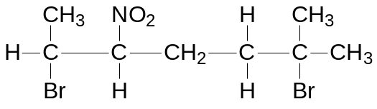
 | C | 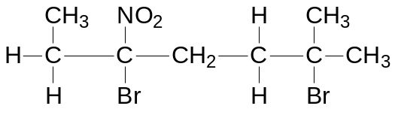
 | D | 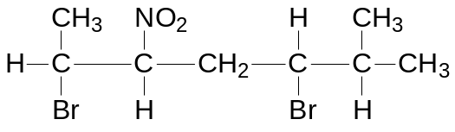

15 | Which one of the following will be formed when butane-1,3-diol is distilled with hot acidified potassium dichromate(VI)?
 | A | CH₃COCH₂CHO
 | B | CH₃COCH₂COOH
 | C | CO₂ and H₂O
 | D | CH₃CH(OH)CH₂COOH

16 | 1 mol of organic compound N undergoes elimination with ethanolic sodium hydroxide to form 2 mol of HBr.  What could compound N be?
  A  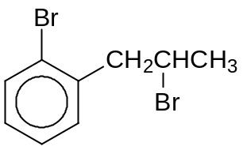 | B  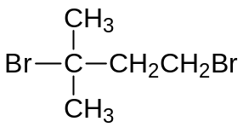
  C  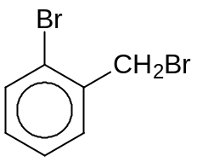 | D  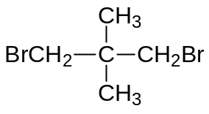

17 | Experiments are carried out on three compounds R, S and T.  A sample of 0.01 mol of each compound is heated under reflux with 50 cm³ of 1.0 mol dm⁻³ aqueous NaOH (in excess) until hydrolysis is completed and any ammonia produced is expelled from solution. The excess NaOH is found to require 20 cm³, 30 cm³ and 40 cm³ of 1.0 mol dm⁻³ HCl for neutralization.  Which sequence of compounds matches the above results?
  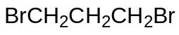 | 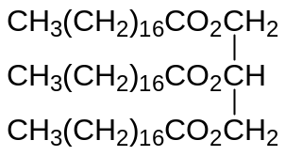 | 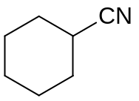
  R | S | T
 |  | 20 cm³ of HCl required | 30 cm³ of HCl required | 40 cm³ of HCl required
 | A | R | S | T
 | B | R | T | S
 | C | S | R | T
 | D | T | S | R

18 | Which reagent gives the same visible observation with propanoic acid and propanal?
 | A | Dilute aqueous sodium carbonate
 | B | Alkaline aqueous iodine
 | C | Sodium metal
 | D | Tollen’s reagent

19 | Terephthalaldehyde is used as an intermediate for manufacturing of dyes and fluorescent whitening agents. It can be synthesized from 4-methylbenzoic acid via a 3-step synthesis.  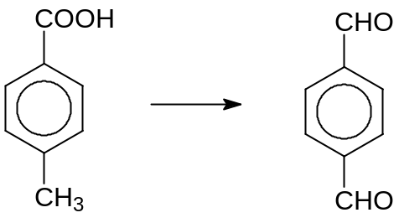  3 steps  4-methylbenzoic acid Terephthalaldehyde  Which of the following reagents and conditions are needed for the conversion?
 |  | Step1 | Step2 | Step3
 | A | Cr₂O₇²⁻ / H⁺, heat to distill | LiAlH₄, r.t.p | Hot KMnO₄ / H⁺
 | B | Cr₂O₇²⁻ / H⁺, heat to distill | NaBH₄, r.t.p | Hot KMnO₄ / H⁺
 | C | Hot KMnO₄ / H⁺ | LiAlH₄, r.t.p | Cr₂O₇²⁻ / H⁺, heat to distill
 | D | Hot KMnO₄ / H⁺ | NaBH₄, r.t.p | Cr₂O₇²⁻ / H⁺, heat to distill

20 | A compound V gives compound W, C₈H₈O, on oxidation under appropriate conditions. W gives a precipitate on warming with Fehling’s reagent.  Which of the following could be V?
 | A | 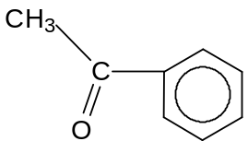
 | B | 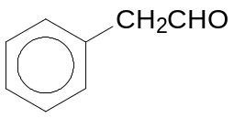
 | C | 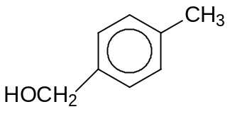
 | D | 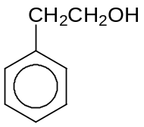

21 | The structure of an organic compound X is shown below:  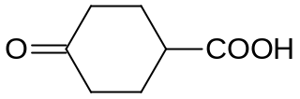  Compound X  Which one of the following statements is true?
 | A | The six-membered carbon ring in X is planar.
 | B | X reacts with cold HCN under basic conditions.
 | C | X does not give an orange precipitate with 2,4-dinitrophenylhydrazine.
 | D | Reaction of sodium carbonate with X produces a gas which turns aqueous red litmus blue.

22 | Which of the following statement is true when the compound below reacts with hot aqueous NaOH?  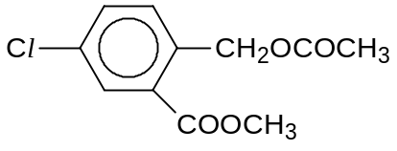
 | A | White fumes are observed.
 | B | A white precipitate is observed.
 | C | Neutralisation has taken place.
 | D | The isolated final product has a low melting point.

23 | A food chemist wants to create the odour of green apples for a product. An ester with this odour has the formula C₂H₅CO₂CH(CH₃)₂. In which of the following will the substances react together to produce this ester?
 | A | C₂H₅OH and (CH₃)₂CHCOOH
 | B | CH₃COOH and CH₃CH(OH)CH₂CH₃
 | C | C₂H₅COOH and C₂H₅CH₂OH
 | D | C₂H₅COOH and (CH₃)₂CHOH

24 | An unknown element forms a chloride which is able to give an acidic solution and an oxide which can dissolve readily in an acidic solution.  What could this element be?
 | A | Calcium
 | B | Aluminium
 | C | Silicon
 | D | Phosphorus

25 | Use of the Data Booklet is relevant to this question.  The graph below shows the second ionisation energies of elements 1 to 4.  The elements are adjacent to each other in the Periodic Table.  Second ionisation energy (arbitrary units)  Atomic number  1  2  3  4  Which statement about the elements 1 to 4 is correct?
 | A | The melting point of the elements increases in the order of 1 > 2 > 3 > 4
 | B | The atomic radius of the elements decreases in the order of 2 < 3 < 4 < 1
 | C | The electrical conductivity of the elements increases in the order 1 < 2 < 3 < 4
 | D | The third ionisation energy of the elements decreases in the order of 3 < 2 < 1 < 4

For questions 26 – 30, one or more of the numbered statements 1 to 3 may be correct. Decide whether each of the statements is or is not correct. The responses A to D should be selected on the basis of
A | B | C | D
1, 2 and 3  are correct | 1 and 2 only  are correct | 2 and 3 only  are correct | 1 only  is correct

No other combination of statements is to be used.

26 | Which of the following contain(s) hydrogen bonds?
 | 1 | NH₄Cl (s)
 | 2 | NH₃ (l)
 | 3 | HNO₃ (l)

A | B | C | D
1, 2 and 3  are correct | 1 and 2 only  are correct | 2 and 3 only  are correct | 1 only  is correct

27 | The kinetics of the reaction between compounds Y and Z were shown in the graph below:  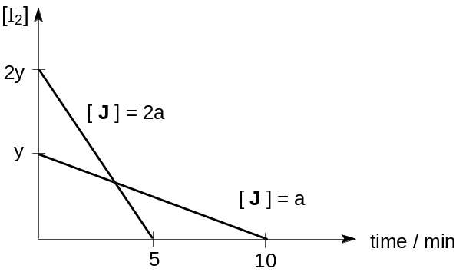  [Y]  [Z] = 2 x  [H] = 2x  [Z] = x  Which of the following conclusion(s) can be drawn from the graph?
 | 1 | The reaction is first order with respect to compound Y.
 | 2 | The reaction is second order with respect to compound Z.
 | 3 | The overall order of reaction is 2.

28 | In an acid-base titration, 25.0 cm³ of 0.150 mol dm⁻³ HCl was titrated with 0.150 mol dm⁻³ NH₃. The table below shows the data of four acid-base indicators.  Which of the following correctly represent(s) the appropriate indicator(s) used in the above titration?
  Indicator | Approximate pH range
  Congo red | 3.0 – 5.0
  Bromocresol green | 3.8 – 5.5
  Cresol red | 7.2 – 8.8
 | 1 | Congo red
 | 2 | Bromocresol green
 | 3 | Cresol red

A | B | C | D
1, 2 and 3  are correct | 1 and 2 only  are correct | 2 and 3 only  are correct | 1 only  is correct

29 | The structure of compound B is shown below:  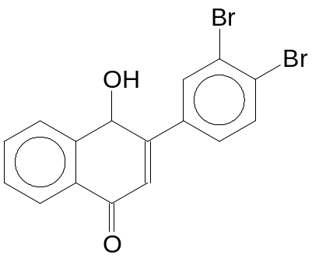  Compound B  What types of reaction will compound B undergo?
 | 1 | Electrophilic substitution and condensation
 | 2 | Nucleophilic substitution and elimination
 | 3 | Neutralisation and nucleophilic addition

30 | Compound C can be formed from ethanal in three steps:  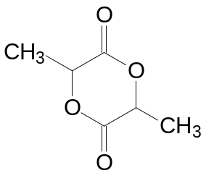  CH₃CHO  Ethanal  3 steps  Compound C  Which of the following reagent(s) and condition(s) is / are required?
 | 1 | Dilute H₂SO₄, reflux
 | 2 | Excess concentrated H₂SO₄, reflux
 | 3 | HCN in aqueous NaOH, cold

-END OF PAPER-

